1. **Advantages of Ordered Arrays**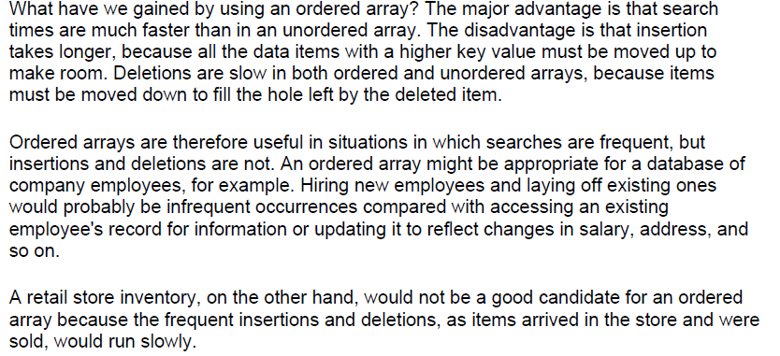
2. 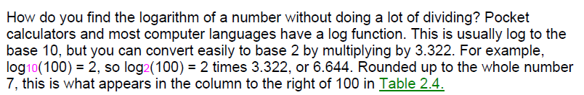

**Summary**

• Arrays in Java are objects, created with the new operator.

• Unordered arrays offer fast insertion but slow searching and deletion.

• Wrapping an array in a class protects the array from being inadvertently altered.

• A class interface comprises the methods (and occasionally fields) that the class user

can access.

• A class interface can be designed to make things simple for the class user.

• A binary search can be applied to an ordered array.

• The logarithm to the base B of a number A is (roughly) the number of times you can

divide A by B before the result is less than 1.

• Linear searches require time proportional to the number of items in an array.

• Binary searches require time proportional to the logarithm of the number of items.

• Big O notation provides a convenient way to compare the speed of algorithms.

• An algorithm that runs in O(1) time is the best, O(log N) is good, O(N) is fair, and O(N2)

is pretty bad.